BIG CASH 7 BINGO

Saturday, April 29th 2023
$60 per person-INCLUDES: Dinner,
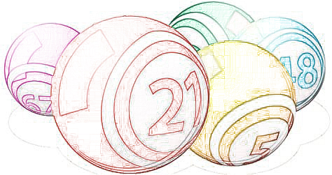
Block of 6 (13 games) Regular Bingo & 1 Strip of 3 (7 games) Jackpot Bingo & 1 SUPER 7

Doors Open 3:37pm-Dinner 4:07 to 5:07pm
Bingo at 5:37pm
Catered Dinner by Mission BBQ
5102 Pegasus Ct. Suite 101 Frederick, Md 21704

EXTRA GAME PAPERS ON SALE from 3:47pm to 5:37pm
SUPER 7 PAYS $777 13 REGULAR GAMES PAY $177
Jackpots pay
$377/$477/$577/$677/$777/$877/$977

For more information or to RESERVE A TICKET call Debbie Ferrell (301-471-7007) or Michele Dilling (240-409-4114)
To purchase tickets online use the following link https://square.link/u/Sm8s71u2
A $3.50 charge will be added to all online and credit card sales
Only 260 Tickets to be sold
Dinner orders based on Advances Ticket Sales. Please Reserve Seat by April 16th 2023 so we can get an accurate head count.
We reserve the right to reduce payouts if less than 190 people.
“NO REFUNDS”

ALL PROCEEDS TO BENEFIT:
THE FREDERICK COUNTY VOLUNTEER FIRE & RESCUE ASSOCIATION
ATM available on site
To be held at the Libertytown Volunteer Fire Dept.
12027 South Street in Libertytown

